“Heaven’s Light is Our Guide”

Rajshahi University of Engineering & Technology



Department of Electrical and Computer Engineering

**Course No:** ECE-3118

**Course Title:**  Software Engineering & Information System Design Sessional

|  |  |
| --- | --- |
| **Submitted by:** | **Submitted to:** |
| **Name:** Nusrat Jahan Nishat  **Roll:** 1810041  **Session:** 2018-19 | Rakibul Hassan  Lecturer  Dept. of ECE |
|  | Rajshahi University of |
|  | Engineering & Technology |

**Experiment No: 01**

**Experiment Name:** Study and analysis of markdown language and documentation and implementation of documentation using markdown language.

**Objectives:** The objectives of this experiment are to learn about the markdown language, its documentation and how it can be implemented.

**Introduction:** Software documentation is any documentation created to help users or developers understand a piece of software’s features and functions. This [type of technical documentation](https://whatfix.com/blog/types-of-technical-documentation/) consists of written tutorials, videos, user guides, and [training manuals](https://whatfix.com/blog/training-manuals/), which aim to aid users in comprehending a piece of software’s features, operations, and functionality. Documentation must comprise an interactive user experience, information architecture, and good understanding of audience. Good documentation practices are important for the success of the software.

Markdown is a lightweight markup language for creating formatted text using a plain-text editor. Generally markdown language is used for documentation

**Tools:** VS code

**Code & Output:**

Code 1:



Output:

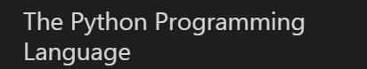

Code 2:



Output:



Code 3:

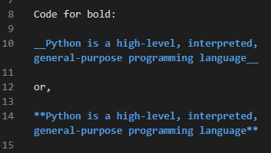

Output:



Code 4:

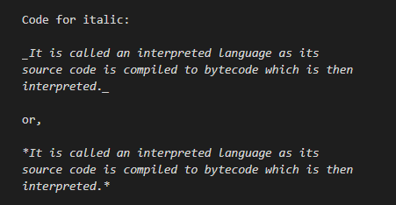

Output:



Code 5:

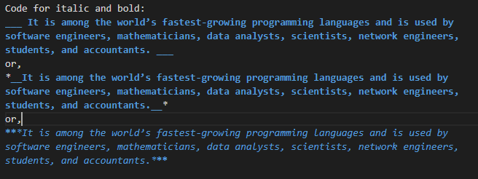

Output:

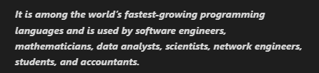

Code 6:

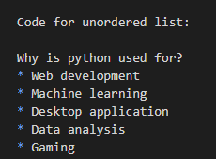

Output:

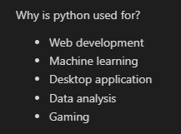

Code 7:

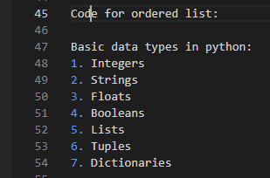

Output:

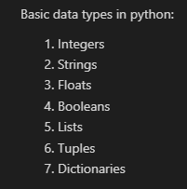

Code 8:

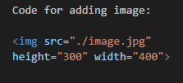

Output:

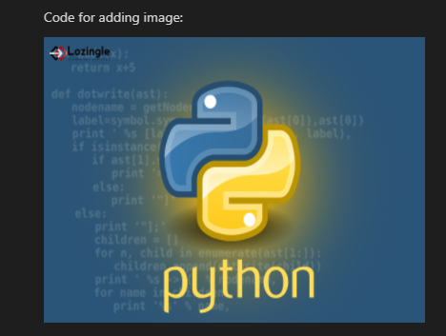

Code for code snippet:

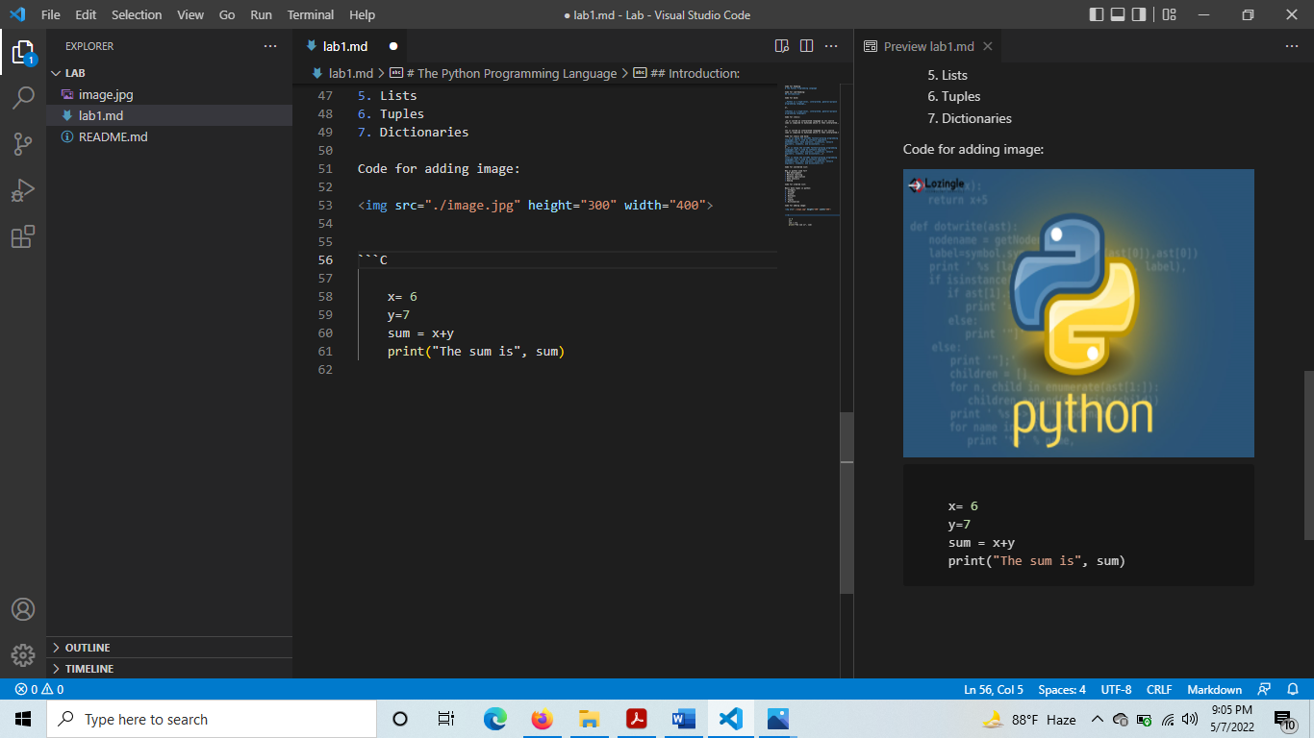

Output:



**A documentation on python programming language will look like as follows:**

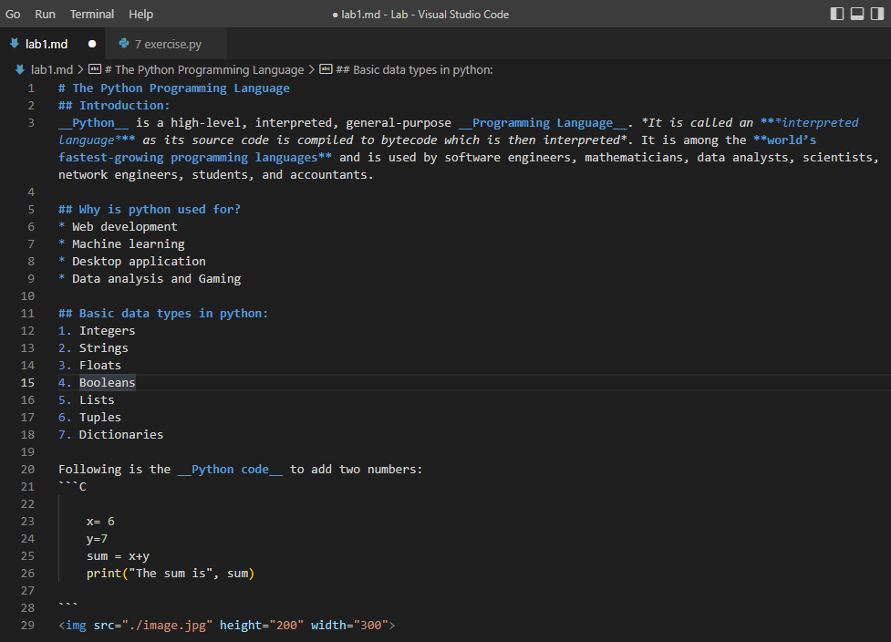

Output:

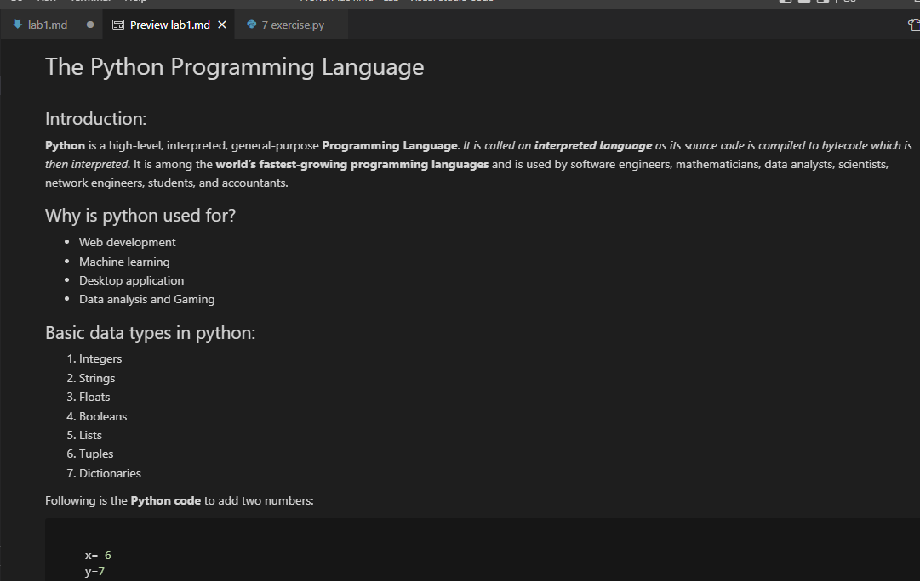

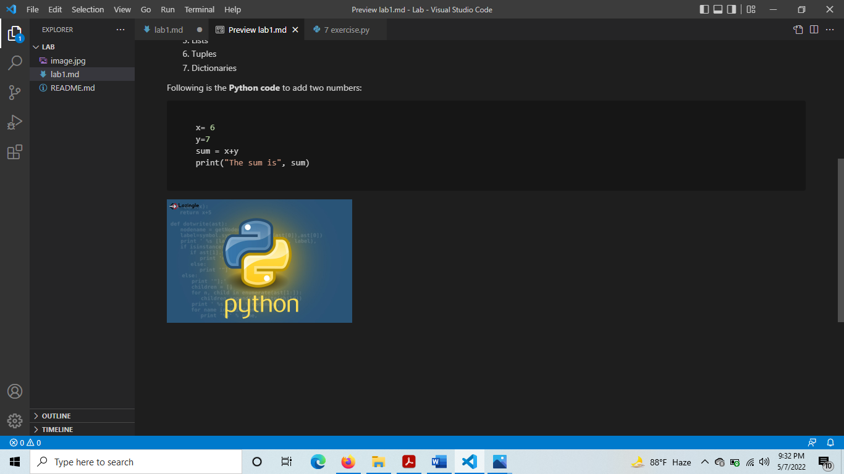

**Conclusion:** Markdown is a great tool for easily making formatted text files that display across a variety of platforms. It’s popular with technical writers for its ease of use and relatively short learning curve.